ILP Project Plan:

Improving and Increasing Knowledge of The Unreal Engine

# Project Overview:

For the independent learning plan, I have been asked to further develop a certain skill within game development, I have chosen to broaden my knowledge of unreal engine game development. I will learn and showcase different aspect of development within the unreal engine, the techniques I want to explore are as followed

* Audio Implementation
* Visual effects
* Cinematic Cutscenes
* Lighting

I will present this project in a single unreal scene and will include the aspects above.

# Reasoning

The reasoning behind this project:

* Increase employability
* Add additional engine to my catalogue of knowledge
* Additional work to add to my portfolio
* Adding additional skill/tools that I haven’t learnt or used before
* Improve the overall quality of game I create using the skills I learn.

# Standards:

The standards of each technique are as followed;

Audio Implementation:

The aspects of audio I will be exploring will be implementing ambient and environmental game music and sound effects. I will demonstrate different types of attenuation shapes and how they affect the way the sound is heard. I will also be exploring reverb effect and how they can craft the overall feel of the environment the player is in.

* Effect refers to diegetic sounds during gameplay that are produced: specifically, footsteps, gunshots, explosions. Call of duty is a great example of a game that uses these sound effects.
* Game music also known as Zone, “refers to environmental sound, these sounds are diegetic and set the game ambience”. (Quinn, 2008). A video I watched showed how different Zone audio effects the games ambience. (UT3 Ambient Passes, 2008).

Visual Effects:

The aspect of visual effect I will be exploring and demonstrating will be creating different particle effects using the cascade tool within the particle system. I will also explore how to optimize these effects, so they don’t hinder performance. From my research I have noticed similarities between the effects used within other games and projects (Appendix B), the similarities include;

* Main body effect
* Additional effect on the edges, small sparks, fire embers, smoke
* Most effects are linear; however, some have noise in other directions
* Self-Illumination is used in most effects

Cinematic Cutscenes:

I will create and demonstrate a short cinematic cutscene using multiple camera’s, I will cycle through these cameras to give different perspective on the scene. I will also add a few skeletal meshes and add animation tracks to them. I will be using the sequencer tool within unreal to create the cutscene.

Lighting:

I will demonstrate lighting a scene depending on the environment

# Management Technique:

To achieve these goals, I will be working on the project for 8 – 16 hours a week. I will be using the agile management style as it gives me the freedom to go back during development. I will be using Trello to set and manage task and clockify to time them accurately.

Over the development process there is always the chance of risks, below is a risk assessment table for the possible outcomes (Appendix A).

I have also completed a work breakdown structure that clearly lays out the structure of the project, and my estimated time split of each aspect of the project (Appendix F).

# Appendix

# Appendix A

# Outline the steps/plan for your project:

|  |  |  |
| --- | --- | --- |
| **Project Milestones** | | |
| **2018-2019** | **Week #** | **Milestone Deliverables and Tasks** |
| 14/11/18 – 21/11/18 | Week 1 | Research and planning project, writing project plan |
| 21/11/18 – 28/11/18 | Week 2 | Continuing project plan ready for hand in |
| 28/11/18 – 5/11/18 | Week 3 | Creating scene in unreal, importing any assets required |
| 5/12/18 – 12/12/18 | Week 4 | Decide on the design and theme of the level |
| 12/12/18 – 19/12/18 | Week 5 | Researching audio techniques used in games and other projects |
| 19/12/18 – 26/12/18 | Week 6 | Implementing audio into my scene |
| 26/12/18 – 2/1/19 | Week 7 | Continue to iterate audio in my scene |
| 2/1/19 – 9/1/19 | Week 8 | Continue to iterate audio in my scene |
| 9/1/19 – 16/1/19 | Week 9 | Continue to iterate audio in my scene |
| 16/1/19 – 23/1/19 | Week 10 | Find and fix issues/bugs with audio |
| 23/1/19 – 30/1/19 | Week 11 | Research Cinematic Cutscenes, research sequencer editor |
| 30/1/19 – 6/2/19 | Week 12 | Implement Cutscene into scene |
| 6/2/19 – 13/2/19 | Week 13 | Continue to iterate Cutscene in my scene |
| 13/2/19 – 20/2/19 | Week 14 | Continue to iterate Cutscene in my scene |
| 20/2/19 – 27/2/19 | Week 15 | Find and fix issues/bugs with Cutscene |
| 27/2/19 – 6/3/19 | Week 16 | Research Lighting from other games and projects |
| 6/3/19 – 13/3/19 | Week 17 | Implement Lighting into scene |
| 13/3/19 – 20/3/19 | Week 18 | Continue to iterate Lighting in my scene |
| 20/3/19 – 27/3/19 | Week 19 | Continue to iterate Lighting in my scene |
| 27/3/19 – 3/4/19 | Week 20 | Continue to iterate Lighting in my scene |
| 3/4/19 – 10/4/19 | Week 21 | Find and fix issues/bugs with Lighting |
| 10/4/19 – 17/4/19 | Week 22 | Research particle effects in games and other projects |
| 17/4/19 – 24/4/19 | Week 23 | Research Cascade tool within unreal |
| 24/4/19 – 1/5/19 | Week 24 | Implement Particle effects into scene |
| 1/5/19 – 8/5/19 | Week 25 | Continue to iterate Particles in my scene |
| 8/5/19 – 15/5/19 | Week 26 | Continue to iterate Particles in my scene |
| 15/5/19 – 22/5/19 | Week 27 | Continue to iterate Particles in my scene |
| 22/5/19 – 29/5/19 | Week 28 | Find and fix issues/bugs with Particle Effects |
| 29/5/19 – 5/6/19 | Week 29 |  |
| 5/6/19 – 12/6/19 | Week 30 |  |
| 12/6/19 – 19/6/19 | Week 31 |  |
| 19/6/19 – 26/6/19 | Week 32 |  |
| 26/6/19 – 3/7/19 | Week 33 |  |
| 3/7/19 – 10/7/19 | Week 34 |  |
| 10/7/19 – 19/7/19 | Week 35 |  |

# Appendix B

Particle effect MoodBoard

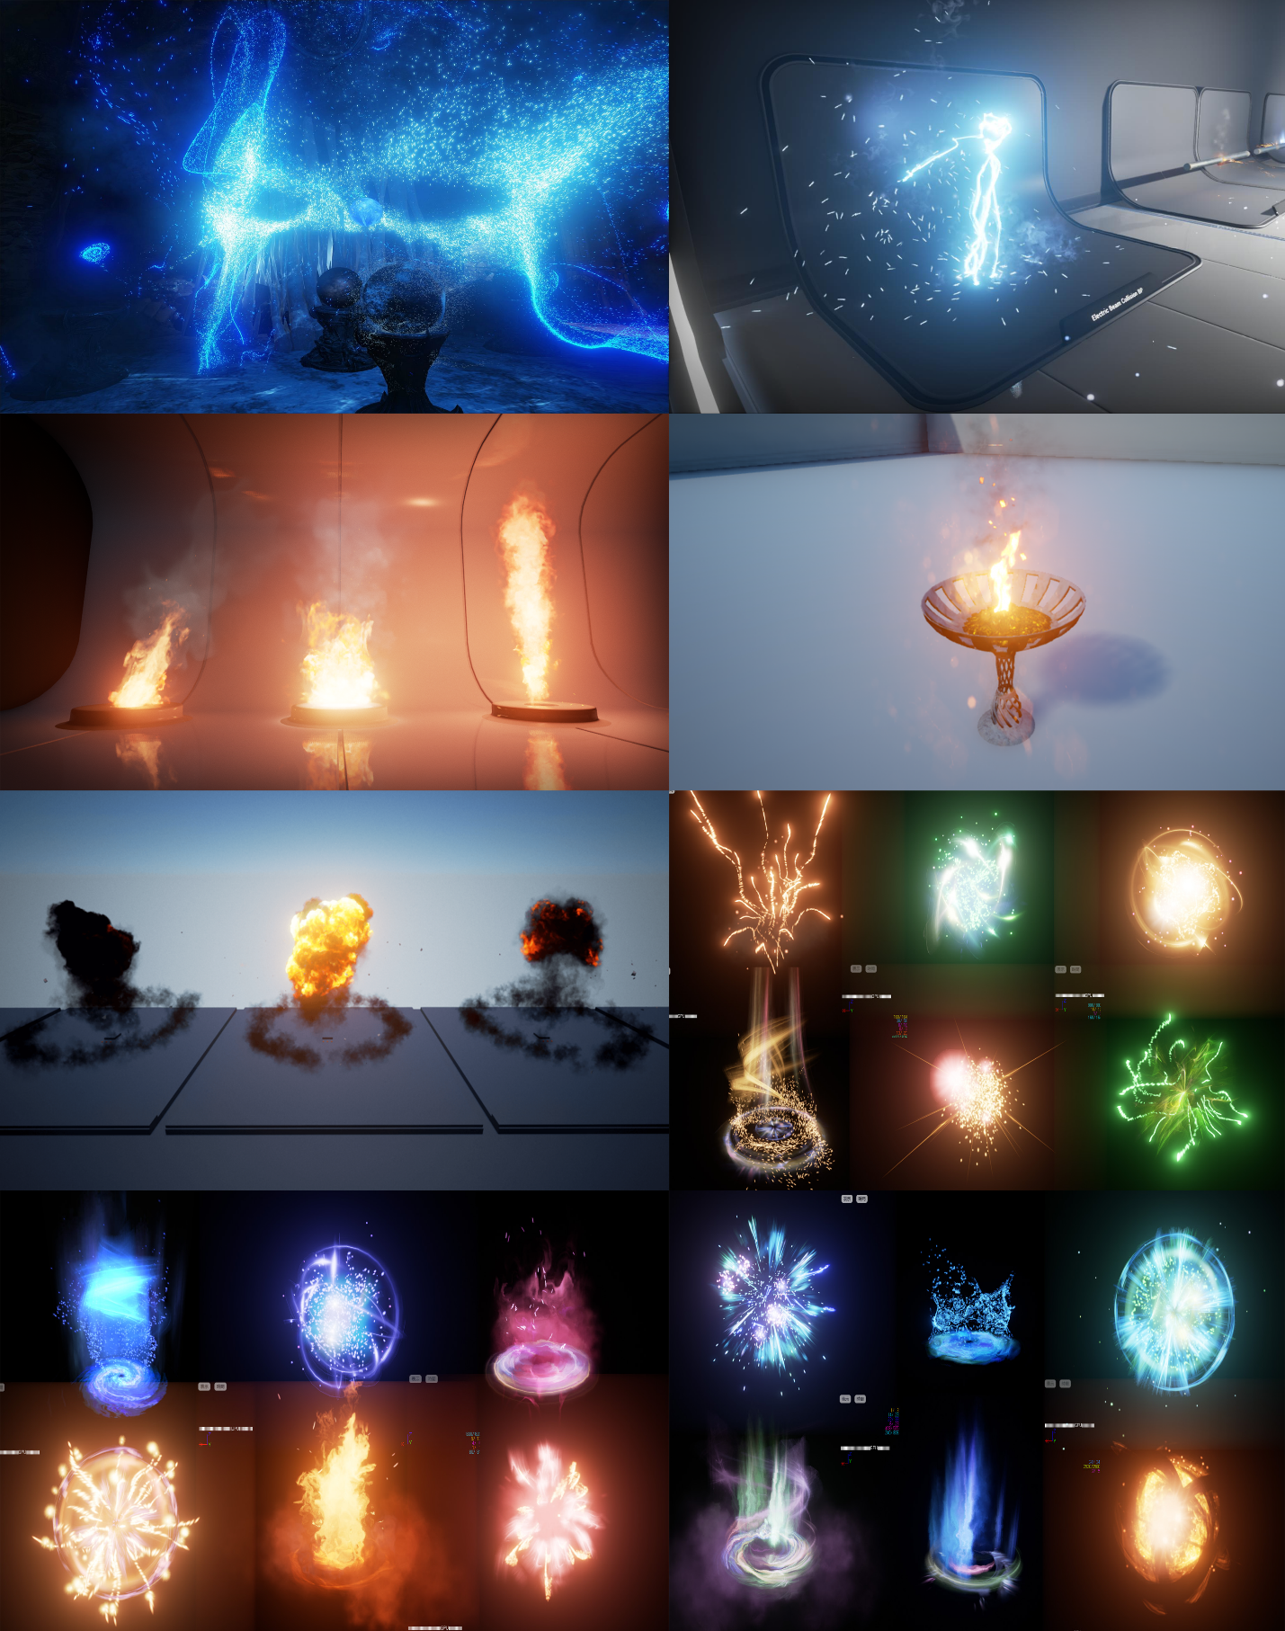

# Appendix C

Sequencer MoodBoard

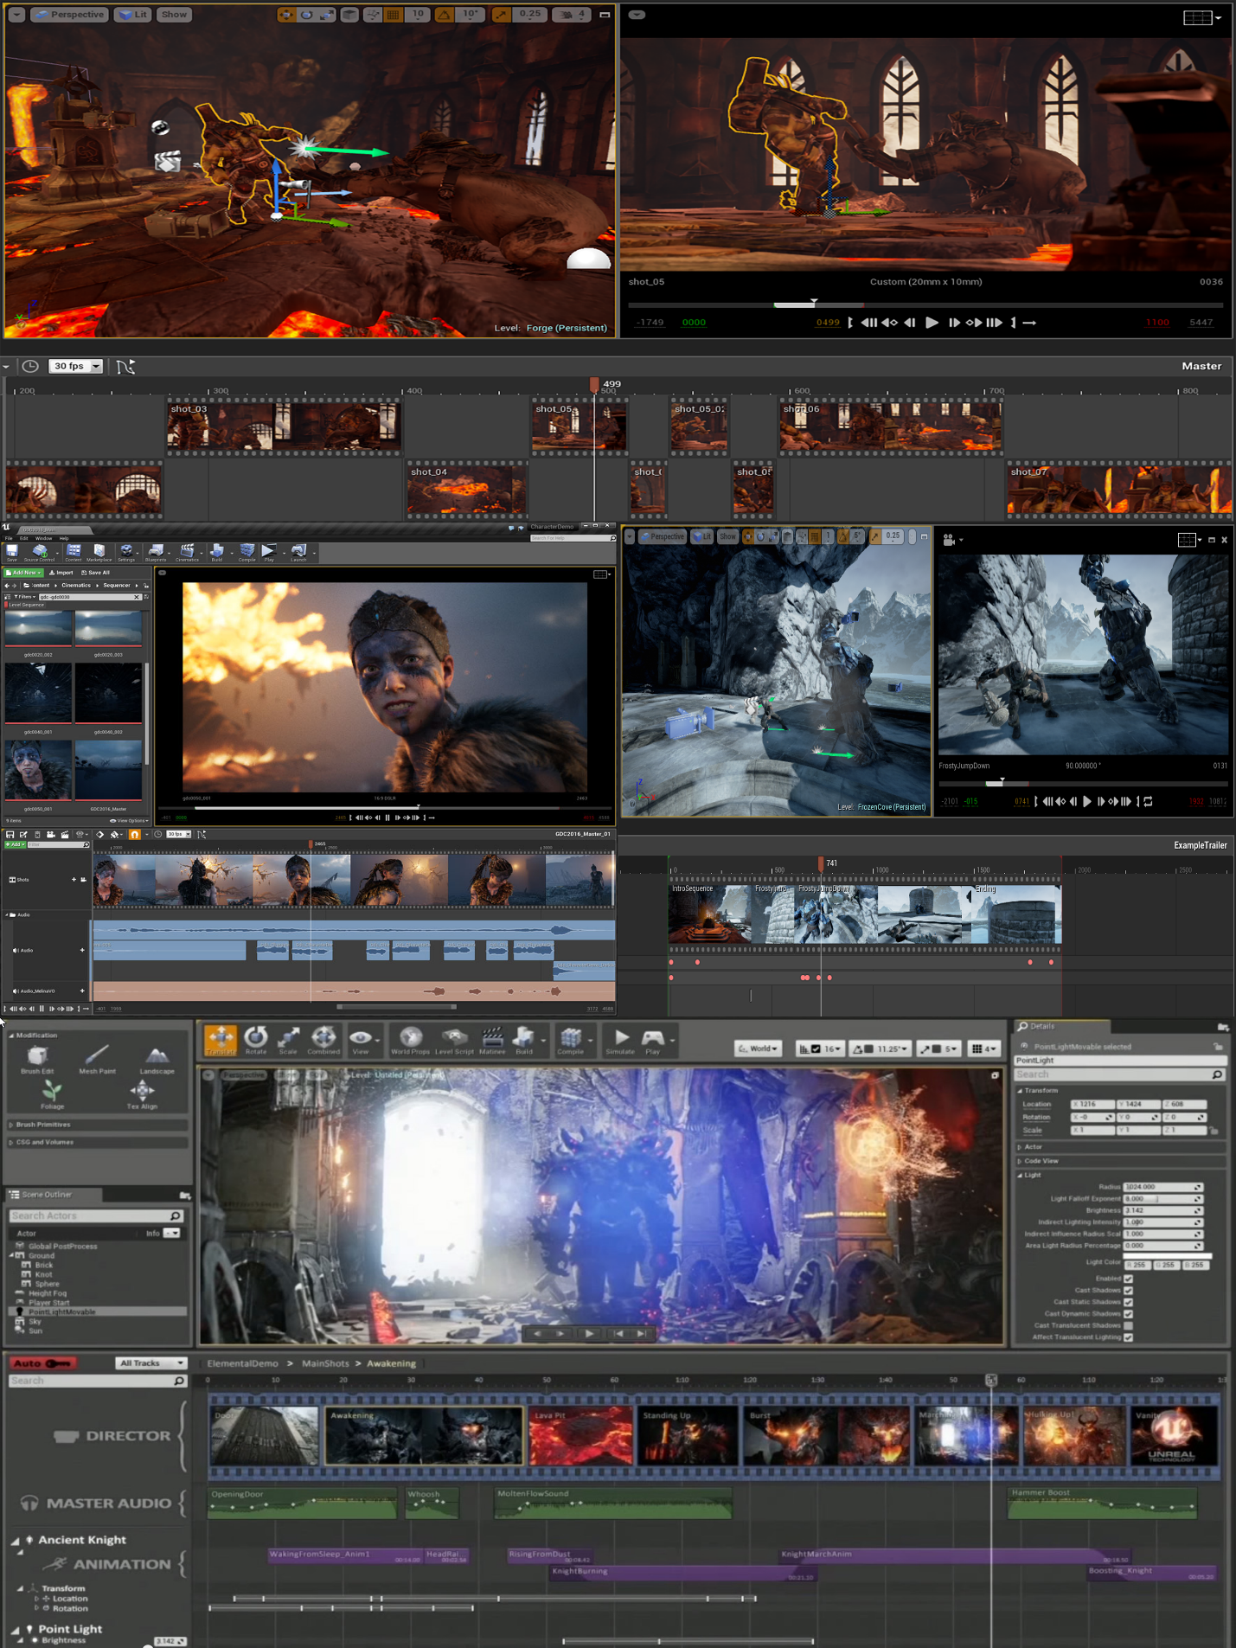

# Appendix D

Lighting the scene

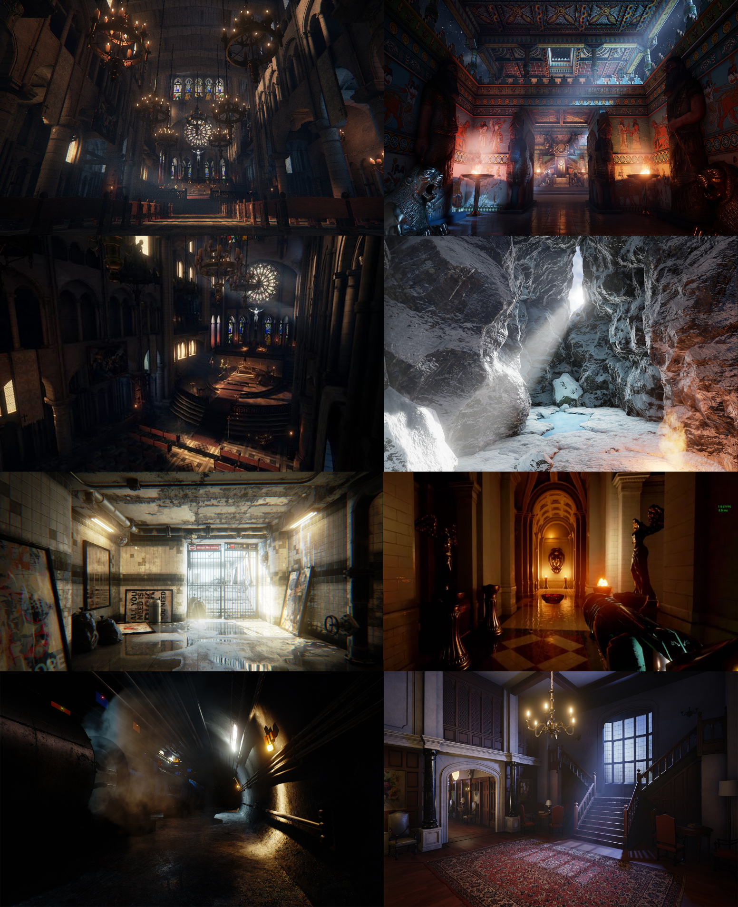

# Appendix E

# 

# Appendix F

Possible Risks

* Over scope
* Technical Software issues
* Overlapping assignments
* Not completing tasks on time
* Spending too much time on research
* Not enough research

|  |  |  |  |
| --- | --- | --- | --- |
| **Likelihood** | **Impact** | **Combined** | **Risk** |
| 1 | 2 | 3 | Over scoping the project |
| 2 | 1 | 3 | Technical issues with unreal or tools within unreal, could cause delays on the project |
| 4 | 4 | 7 | Not researching enough for the project |
| 3 | 3 | 6 | Spending too much time researching and not implementing. |
| 6 | 6 | 12 | Not completing takes according to the week by week schedule |
| 5 | 5 | 10 | Overlapping assignments may cause schedule issues |

# Bibliography

Quinn, A. (2008). Types and Roles Of Sound In Games. [Blog] *Andrew Quinn, Sound Designer & Field Recordist*. Available at: http://www.aquinn.co.uk/wordpress/7 [Accessed 20 Nov. 2018].

*UT3 Ambient Passes*. (2008). [video] Directed by A. Quinn. Youtube.

Schmalz, M., Finn, A. and Taylor, H. (2014). Risk Management in Video Game Development Projects. *2014 47th Hawaii International Conference on System Sciences*. [online] Available at: https://ieeexplore.ieee.org/document/6759136 [Accessed 20 Nov. 2018].